**Homework 10 (Week-16): Log-Rank Test** 公衛二 梁嫚芳 B07801003

Given the remission time data (Z; δ ; X1 ; X2), where X1 is the treatment status (X1 = 1 for treatment, and X1 = 0 for placebo), and X2 is the measurement of WBC. Define WBC- status to be X*2 = Low if X2 < median(X2), and X*2 = High if X2 ≥ median(X2). Use (stratified) log-rank test to answer the following questions (write down the hypothesis, obtain the log-rank test statistic by R, and make conclusions under the significance level α = 0.05).

1. **Is WBC-status influential to remission time?**

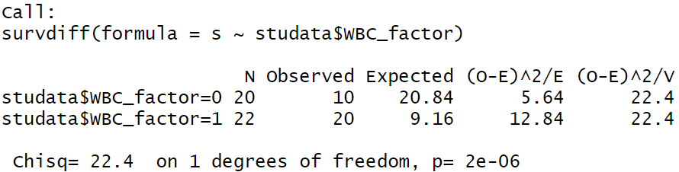

H0: S0(t)=S1(t)

H1: S0(t)≠S1(t)

S0(t) : Survival function of X*2=0

S1(t) : Survival function of X*2=1

test statistic: χ2=5.64+12.84=18.48

p-value=2e-06 <α(0.05), reject H0, S0(t)≠S1(t). WBC-status is influential to remission time.

1. **Are the treatment status and WBC-status influential to remission time?**

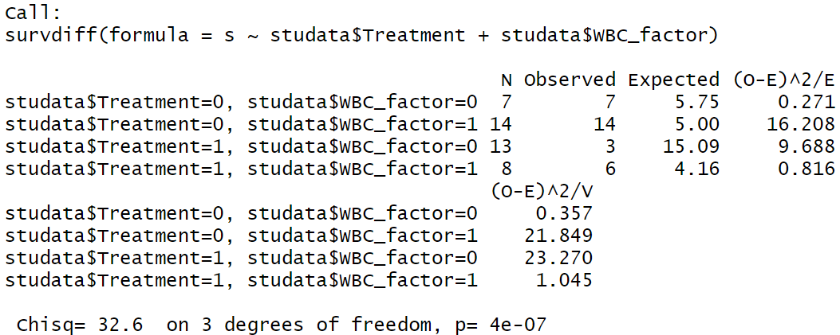

H0: S0(t)=S1(t)=S2(t)=S3(t)

H1: S0(t),S1(t),S2(t),S3(t)不均相等

S0(t) : Survival function of X1=0, X*2=0

S1(t) : Survival function of X1=0, X*2=1

S2(t) : Survival function of X1=1, X*2=0

S3(t) : Survival function of X1=1, X*2=1

test statistic: χ2=0.271+16.208+9.688+0.816=26.983

p-value=4e-07 <α(0.05), reject H0, S0(t),S1(t),S2(t),S3(t)不均相等. treatment status and WBC-status are influential to remission time.

1. **Is treatment status influential to remission time after controlling the effect of WBC- status?**

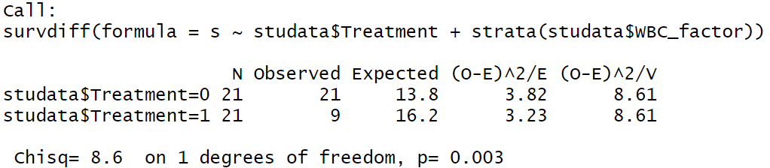

H0: S0(t)=S2(t)

H1: S0(t)≠S2(t)

&

H0: S1(t)=S3(t)

H1: S1(t)≠S3(t)

S0(t) : Survival function of X1=0, X*2=0

S1(t) : Survival function of X1=0, X*2=1

S2(t) : Survival function of X1=1, X*2=0

S3(t) : Survival function of X1=1, X*2=1

test statistic: χ2=3.82+3.23=7.05‬

p-value=0.003 <α(0.05), reject H0, S0(t)≠S2(t)或S1(t)≠S3(t). Treatment status is influential to remission time after controlling the effect of WBC- status

1. **Is there any evidence to indicate possible interaction between the treatment status and WBC-status? Why? Also plot the KM curves (by R) to support your conclusion.**

根據下圖，比較WBC-status=0與WBC-status=1的各自兩條curve，各自的Treatment status=1的高度皆較Treatment status=0高，且WBC-status=0的兩條curves之高度差距較WBC-status=1大，即WBC-status不同會造成Treatment status=0與Treatment status=1的curves之高度差距效果不同，因此Treatment status和WBC-status有交互作用。Yes, there is evidence to indicate possible interaction between the treatment status and WBC-status.

